Yale-China Association
Chia Family Foundation Health Fellowship Program at Yale
2020-2021 Fellowship Announcement

General Introduction
Made possible by a generous grant from the Chia Family Foundation and the support of Xiangya School of Medicine and Kunming Medical University, the Chia Family Health Fellowship Program seeks to improve the health outcomes of the people of Hunan and Yunnan through supporting research and interventions in medicine, public health, and nursing by promoting the role of early- to mid-career Chinese women in nursing and other health professions.
Four Chia Fellowships at Yale will be awarded for 2020-2021, two for candidates from Hunan and two for candidates from Yunnan. The Chia Fellowship has two components: a semester (6 months, July 1-December 31, 2020) at Yale, followed by project implementation in Hunan or Yunnan.

Program Priorities
There are two distinctive features of the Chia Fellowship. First, it is aimed at advancing the careers of early- to mid-career women in nursing and other health professions. Second, the Chia Fellowship aims to support health projects that are concerned with improving health outcomes of underserved and vulnerable populations in resource-limited communities, through strengthening health service delivery and health system quality, improving health equity, and addressing emerging health needs in chronic diseases, mental health, pediatrics, geriatrics, women’s health, and environmental health. Selection of Hunan applications will give priority to projects based in western Hunan.

The Fellowship Program
In the first year of the Chia Fellowship, Chia Fellows will come to Yale for 6 months, including 6 weeks in the summer, and the fall semester 2020. While at Yale, each Chia Fellow will have the opportunity to study and develop their research proposals under the guidance of Yale faculty. By the end of the six months at Yale, each Chia Fellow will submit an application to the Yale University Institutional Review Board (IRB) for the proposed project activities in China that will be conducted upon returning to China, after project approval by the Yale IRB and fellow’s own institutional IRB. Chia Fellows have up to two years to complete their research projects, with project funding support of up to $3,000 provided by the fellowship.

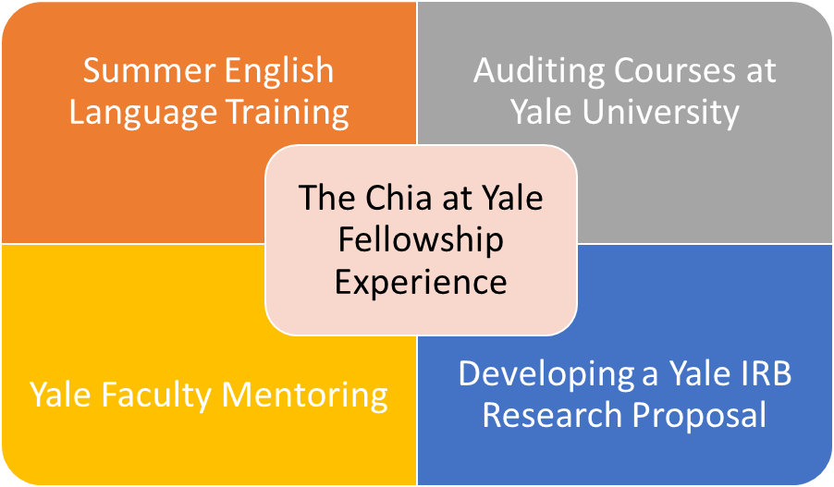

Chia Fellowship Candidate Qualifications and Selection Criteria
Only women working in the fields of nursing, public health and medicine, at Xiangya professional schools and hospitals are eligible to apply for the program. Following a review of proposals submitted by the candidates, a committee composed of representatives of the Yale-China Association and the Xiangya School of Medicine will invite selected candidates for interviews at Xiangya in late October, 2019.

Selection will be based on the following criteria:

- The candidate’s academic and professional strength, and preparedness for the Chia Fellowship Program.
- The candidate’s professional motivation, training and experience.
- Overall assessment of the proposed project according to the following:
--Quality of the research plan
--Feasibility of the research/project plan
--Relevance of the research/project plan to program priorities as stated above
- The availability of an appropriate Yale faculty mentor.
- The likelihood that the proposed work will continue upon return and support from superiors.
- The candidate’s potential to influence health practice and policy in Hunan.
- The candidate’s commitment to community service and potential to continue to work in the same priority areas as outlined by the program.
- The candidate’s English ability. (Candidates are expected to be able to understand English academic lectures, read academic journals, write effectively and clearly in English, and be comfortable speaking in English about their own professional or research work.)
Proposed projects will be judged upon their academic merits and topic, as well as on applicants’ likelihood to continue to work in the priority area, beyond completion of the Chia Fellowship. Chia Fellowship recipients will be announced in late December 2019 or January 2020.

Funding Requirements
One of the fellowships will be funded largely with the generous support of the Chia Family Foundation. The second fellowship is partly funded through your home institution and partly from the Chia Family Foundation, which will provide the $3000 in project funding for the project to be implemented during the two years after your time at Yale. For this partially self-funded fellowship, currently, Yale requires a financial support letter from your institution indicating a monthly minimum salary support of $2,500 for the duration of your stay at Yale, from July 1-December 31.

For ALL applicants, we ask that you provide a letter of support from your institutional leader on the institutional letterhead, indicating their agreement to provide the following funding support for your Fellowship at Yale, including: 1) Round trip travel to the U.S. (including visa related expenses); 2) Minimum $2,500 monthly salary support for six months ($15,000 total) to cover your health insurance costs, rent, utilities, and living stipend for your U.S. visit; 3) $3000 fee to Yale faculty who will serve as your advisor. The letter must indicate that the funding your institution will provide will cover period of the fellowship appointment period from July 1 - December 31, 2019. However, if you are selected for the fully funded fellowship, the Chia family foundation will provide for your airfare, housing and other fees and your institution will not need to provide that support.

Institutions must provide proof of funding for Chia Fellows to Yale-China Association prior to arrival at Yale. Chia Fellows without full funding secured from institutions prior to their arrival may experience a delay in departure, or, in the most extreme cases, selection as a Chia Fellow may be rescinded. Only verified institutional support is acceptable, personal funding is not acceptable.

Application Process and Time Table
Application forms and instructions are available at the International Cooperation Office, Central South University (jessica.hahne@yale.edu) or the Yale-China Office (jessica.hahne@yale.edu). The 2020-2021 Chia Fellowship candidates will be interviewed in October 2019, with final decisions announced in December 2019 or January 2020, which will allow new Chia Fellows ample time to prepare for their studies at Yale the following fall.

Required Application Materials

- Chia Fellowship Application Form (1 page)
- Chia Project Proposal (2-3 pages)
- Curriculum Vitae
- Institutional support letter indicating minimum monthly salary support of $2,500 for the period of July 1 to December 31, 2020 (six months), as well as Yale faculty advisor fee of $3,000, and any visa, travel and health insurance expenses.

Each applicant should submit two copies of the application, one copy to International Cooperation Office, Central South University (in person or via email to xcwu@csu.edu.cn) and one copy to Yale-China (via email to jessica.hahne@yale.edu) by Friday, October 4th, 2019. Applicants from Xiangya’s affiliated hospitals must notify the hospital international office of your intention to apply for the Chia Fellowship. Please send your applications to the following emails or contact the following offices if you have questions. Incomplete applications will not be accepted. Applicants selected for an interview will be notified.

Dr. WU Xiaochuang  Deputy Dean  Xiangya School of Medicine  Central South University  110 Xiangya Road  Changsha, Hunan, 410078  Fax: 86-731-84805209  Email: xcwu@csu.edu.cn | Yale-China Association  P.O. Box 208223  New Haven, CT 06520 USA  Tel: (1)203-432-0880  Fax: (1)203-432-7246  Website: www.yalechina.org  Email: jessica.hahne@yale.edu

